
International School
Capstone Project 1
CMU-SE 450 – C1SE.06
Database Design
Version 1.1
Date: Nov 4th, 2026
SFDS
Scam Fraud Detection System with Explanations
Created by
Hao, Pham Tan
Nhung, Dao Thi My
Nam, Tran Hoang Nhat
Tuan, Nguyen Phan Duc
Approved by
Eng. Toan, Ha Manh
Database Design Review Panel Representative:
Name: ________________________ Signature: ________________________ Date: ____________
Capstone Project 1 - Mentor:
Name: ________________________ Signature: ________________________ Date: ____________

PROJECT INFORMATION
Project acronym | SFDS
Project Title | “SFDS” – Scam Fraud Detection System with Explanations
Start Date | 02 Sep 2026 | End Date | 15 Dec 2026
Lead Institution | International School, Duy Tan University
Project Mentor | Eng. Ha Manh Toan (Email: lhttuy@gmail.com)
Scrum master / Leader | Hao, Pham Tan  Email: phamtanhao1909@gmail.com  Tel: 0961 651 933  ID: 29219020823
Product Owner / QA | Nhung, Dao Thi My  Email: mynhung150905@gmail.com  Tel: 0376 415 338  ID: 29209200048
Partner Organization | Duy Tan University
Team members:
No. | Name | Email | Tel
1 | Hao, Pham Tan | phamtanhao1909@gmail.com | 0961651933
2 | Nhung, Dao Thi My | mynhung150905@gmail.com | 0376415338
3 | Nam, Tran Hoang Nhat | trannamnhathoang@gmail.com | 0795798736
4 | Tuan, Nguyen Phan Duc | ductuan02072005@gmail.com | 0932442770

DOCUMENT APPROVALS
The following signatures are required for approval of this document.
Stakeholder | Signature | Date
Hao, Pham Tan  Student ID: 29219020823  Scrum Master / Leader | Signature: _______________ | Date: 04/11/2026
Nhung, Dao Thi My  Student ID: 29209200048  Product Owner / QA Lead | Signature: _______________ | Date: 04/11/2026
Nam, Tran Hoang Nhat  Student ID: 29219423638  Frontend Developer | Signature: _______________ | Date: 04/11/2026
Tuan, Nguyen Phan Duc  Student ID: 29211151140  AI Lead | Signature: _______________ | Date: 04/11/2026
Eng. Ha Manh Toan  Project Mentor  Duy Tan University | Signature: _______________ | Date: 04/11/2026

DATABASE DESIGN DOCUMENT
Attribute | Specification
Document Title | Database Design Document (SFDS)
Author(s) | Hao, Pham Tan
Date | Nov 4th, 2026
File name: | C1SE.06_DatabaseDesign_v1.1.docx

REVISION HISTORY
Version | Date | Comments | Author | Approval
1.1 | Nov 4th, 2026 | Official Database Design Document for SFDS Capstone | Hao, Pham Tan | Eng. Ha Manh Toan

TABLE OF CONTENTS
1. Introduction 7
1.1 Purpose 7
1.2 Scope 7
1.3 Introduction about Relational Database Management System (MySQL & SQLite) 7
2. Database Diagram 9
2.1 Table Overview 9
2.2 Table Relationship Diagram 9
3. Database Design for Sprint 11
3.1 Table users 11
3.2 Table auth_identities 12
3.3 Table scam_categories 13
3.4 Table scan_history 13
3.5 Table incidents 15
3.6 Table scam_keywords 16
3.7 Table training_dataset 17
3.8 Table ai_models 18
3.9 Table model_evaluations 19
3.10 Table system_activity_logs 20
4. Hardware and software Requirements 21

1. Introduction
The Database Design maps the logical data model to the target database management system with strict consideration to the system's performance requirements. The Database Design converts logical or conceptual data constructs to physical data constructs (tables, columns, indexes, foreign keys, and constraints) of the target Database Management System.

1.1 Purpose
The purpose of the Database Design is to ensure that every database transaction meets or exceeds its performance requirements. This document takes into account data and transaction volume to produce a schema and environment that will meet necessary performance.

1.2 Scope
The Database Design Document has the following objectives:
- To describe the design of a database, that is, a collection of related data stored in one or more computerized files that can be accessed by users or developers via a DBMS.
- To serve as a basis for implementing the database and related software units. It provides the acquirer visibility into the design and provides information necessary for software development.

1.3 Introduction about Relational Database Management System (MySQL & SQLite)
MySQL is an open-source relational database management system (RDBMS) that stores data in structured tables composed of rows and columns. It uses Structured Query Language (SQL) to define, manipulate, and query data. Unlike NoSQL document databases, MySQL enforces strict ACID (Atomicity, Consistency, Isolation, Durability) transactions, making it exceptionally well-suited for forensic investigations, audit tracking, and fraud classification where referential integrity and zero data loss are mandatory.
In the SFDS platform, data is organized across 10 normalized tables. MySQL 8.0 powers high-throughput production workloads, while SQLite 3 provides seamless offline and local development capabilities via SQLAlchemy ORM. Native JSON support in MySQL 8.0 allows storing structured relational records (user IDs, timestamps, calibrated risk scores) alongside flexible semi-structured JSON payloads (extracted OCR bounding boxes, forensic flags, and step-by-step Chain-of-Thought explanations) without sacrificing relational guarantees.

2. Database Diagram

2.1 Table Overview
Table 1. Table Overview
Collection / Table Name | Short Description
users | Stores login accounts, credentials, and role-based permissions ('user', 'sme', 'admin').
auth_identities | Links internal user accounts to external OAuth providers (Google, Zalo) for Single Sign-On.
scam_categories | Standardized taxonomy catalog defining cyber fraud categories (phishing, impersonation, fake invoice).
scan_history | Stores forensic scan transactions: input modalities (URL, text, screenshot), risk scores, and AI explanations.
incidents | Manages reported fraud cases, triage workflow statuses ('moi', 'dang_xu_ly', 'da_xu_ly'), and assignees.
scam_keywords | Dictionary of Vietnamese fraud phrases, regex patterns, and risk contribution weights.
training_dataset | Anonymized, verified image and text sample repository utilized for periodic AI model retraining.
ai_models | Model registry cataloging deployed AI engine versions (PhishVN, ResNet-18, CoT reasoning) and active status.
model_evaluations | Benchmark evaluation metrics (Macro F1, Recall, False Alarm Rate, Explanation Usefulness) for AI models.
system_activity_logs | Security audit trail recording administrative actions, rule modifications, and system events.

2.2 Table Relationship Diagram
Figure 1 illustrates the Table Relationship Diagram (ERD) of the SFDS database, depicting all 10 tables, primary keys, foreign keys, and relational cardinality.
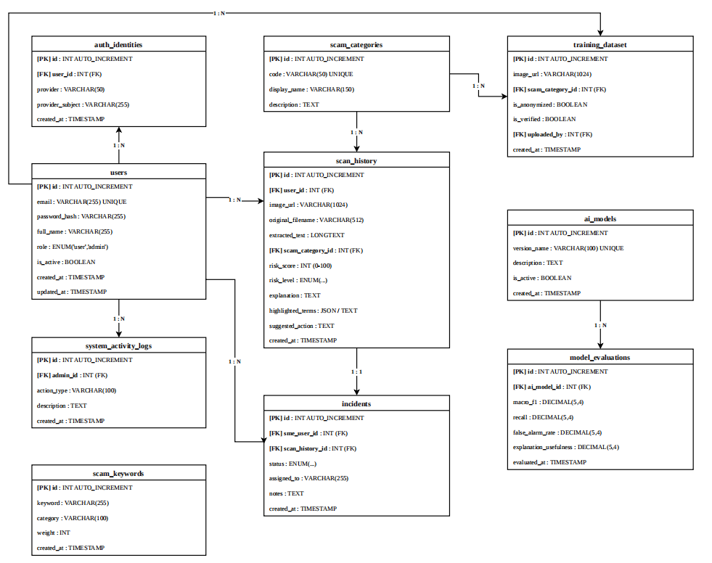
Figure 1. Table Relationship Diagram (ERD)

3. Database Design for Sprint

3.1 Table users
Table 2. Table users
Id | Field | Type | Constraint | Description
1 | id | INT | Primary key, Auto-Increment | Unique auto-generated identifier for the user.
2 | email | VARCHAR(255) | Required, Unique | The user's login email address.
3 | password_hash | VARCHAR(255) | Required | Bcrypt-hashed password string.
4 | full_name | VARCHAR(255) | Optional | The full name of the user.
5 | role | ENUM('user','admin') | Default: 'user' | Role-based access level governing system permissions.
6 | is_active | BOOLEAN | Default: true | Flag indicating whether the account is active.
7 | created_at | TIMESTAMP | Default: CURRENT_TIMESTAMP | Timestamp when the account was created.
8 | updated_at | TIMESTAMP | Default: CURRENT_TIMESTAMP | Timestamp of the last profile update.

3.2 Table auth_identities
Table 3. Table auth_identities
Id | Field | Type | Constraint | Description
1 | id | INT | Primary key, Auto-Increment | Unique identifier for external identity binding.
2 | user_id | INT | Required, Foreign Key | References users(id) ON DELETE CASCADE.
3 | provider | VARCHAR(50) | Required | Name of OAuth provider (e.g., 'google', 'zalo').
4 | provider_subject | VARCHAR(255) | Required | Unique subject ID issued by the OAuth provider.
5 | created_at | TIMESTAMP | Default: CURRENT_TIMESTAMP | Timestamp when OAuth identity was linked.

3.3 Table scam_categories
Table 4. Table scam_categories
Id | Field | Type | Constraint | Description
1 | id | INT | Primary key, Auto-Increment | Unique category identifier.
2 | code | VARCHAR(50) | Required, Unique | Slug code (e.g., 'phishing', 'fake_invoice').
3 | display_name | VARCHAR(150) | Required | Human-readable Vietnamese category name.
4 | description | TEXT | Optional | Detailed description of the scam tactics.

3.4 Table scan_history
Table 5. Table scan_history
Id | Field | Type | Constraint | Description
1 | id | INT | Primary key, Auto-Increment | Unique scan transaction identifier.
2 | user_id | INT | Required, Foreign Key | References users(id) ON DELETE CASCADE.
3 | image_url | VARCHAR(1024) | Optional | Storage URL of suspicious screenshot image.
4 | original_filename | VARCHAR(512) | Optional | Original file name uploaded by the user.
5 | extracted_text | LONGTEXT | Optional | Full Vietnamese text extracted via Tesseract OCR.
6 | scam_category_id | INT | Optional, Foreign Key | References scam_categories(id) ON DELETE SET NULL.
7 | risk_score | INT | Required, Range: 0-100 | Calibrated soft-voting multimodal risk score.
8 | risk_level | ENUM('an_toan','nghi_ngo','nguy_hiem') | Required | Categorical risk classification level.
9 | explanation | TEXT | Optional | Synthesized plain-language reasoning explanation.
10 | highlighted_regions | LONGTEXT / JSON | Optional | JSON coordinates and flagged terms in proof.
11 | suggested_action | TEXT | Optional | Actionable prevention recommendations for user.
12 | created_at | TIMESTAMP | Default: CURRENT_TIMESTAMP | Timestamp when the scan was executed.

3.5 Table incidents
Table 6. Table incidents
Id | Field | Type | Constraint | Description
1 | id | INT | Primary key, Auto-Increment | Unique incident ticket identifier.
2 | sme_user_id | INT | Required, Foreign Key | References users(id) ON DELETE CASCADE.
3 | scan_history_id | INT | Required, Foreign Key | References scan_history(id) ON DELETE CASCADE.
4 | status | ENUM('moi','dang_xu_ly','da_xu_ly','bo_qua') | Default: 'moi' | Investigation workflow lifecycle state.
5 | assigned_to | VARCHAR(255) | Optional | Name of assigned forensic investigator.
6 | notes | TEXT | Optional | Resolution notes and investigative remarks.
7 | created_at | TIMESTAMP | Default: CURRENT_TIMESTAMP | Timestamp when incident was created.
8 | updated_at | TIMESTAMP | Default: CURRENT_TIMESTAMP | Timestamp of the last status update.

3.6 Table scam_keywords
Table 7. Table scam_keywords
Id | Field | Type | Constraint | Description
1 | id | INT | Primary key, Auto-Increment | Unique keyword identifier.
2 | keyword | VARCHAR(255) | Required | Vietnamese fraud keyword or regex pattern.
3 | category | VARCHAR(100) | Required | Fraud category associated with keyword.
4 | weight | INT | Default: 10 | Risk score contribution weight (5-25 points).
5 | created_at | TIMESTAMP | Default: CURRENT_TIMESTAMP | Timestamp when rule was registered.

3.7 Table training_dataset
Table 8. Table training_dataset
Id | Field | Type | Constraint | Description
1 | id | INT | Primary key, Auto-Increment | Unique dataset sample identifier.
2 | image_url | VARCHAR(1024) | Required | Storage path to curated training image/text.
3 | scam_category_id | INT | Optional, Foreign Key | References scam_categories(id) ON DELETE SET NULL.
4 | is_anonymized | BOOLEAN | Default: false | Flag confirming PII has been redacted.
5 | is_verified | BOOLEAN | Default: false | Flag indicating ground truth label is verified.
6 | uploaded_by | INT | Required, Foreign Key | References users(id) ON DELETE CASCADE.
7 | created_at | TIMESTAMP | Default: CURRENT_TIMESTAMP | Timestamp when sample was added.

3.8 Table ai_models
Table 9. Table ai_models
Id | Field | Type | Constraint | Description
1 | id | INT | Primary key, Auto-Increment | Unique AI model identifier.
2 | version_name | VARCHAR(100) | Required, Unique | Model version (e.g., 'PhishVN-v1.2', 'ResNet18-v2.0').
3 | description | TEXT | Optional | Model architecture, hyperparameters, and dataset.
4 | is_active | BOOLEAN | Default: false | Flag indicating if model is currently serving traffic.
5 | created_at | TIMESTAMP | Default: CURRENT_TIMESTAMP | Timestamp when checkpoint was registered.

3.9 Table model_evaluations
Table 10. Table model_evaluations
Id | Field | Type | Constraint | Description
1 | id | INT | Primary key, Auto-Increment | Unique benchmark evaluation identifier.
2 | ai_model_id | INT | Required, Foreign Key | References ai_models(id) ON DELETE CASCADE.
3 | macro_f1 | DECIMAL(5,4) | Optional | Macro F1-score across validation test set.
4 | recall | DECIMAL(5,4) | Optional | Detection recall rate on true fraud samples.
5 | false_alarm_rate | DECIMAL(5,4) | Optional | False positive alarm rate on benign samples.
6 | explanation_usefulness | DECIMAL(5,4) | Optional | Expert score assessing clarity of explanations.
7 | evaluated_at | TIMESTAMP | Default: CURRENT_TIMESTAMP | Timestamp when evaluation was executed.

3.10 Table system_activity_logs
Table 11. Table system_activity_logs
Id | Field | Type | Constraint | Description
1 | id | INT | Primary key, Auto-Increment | Unique log entry identifier.
2 | admin_id | INT | Optional, Foreign Key | References users(id) ON DELETE SET NULL.
3 | action_type | VARCHAR(100) | Required | Action type (e.g., 'UPDATE_RULE', 'TRIAGE_CASE').
4 | description | TEXT | Optional | Detailed description of administrative changes.
5 | created_at | TIMESTAMP | Default: CURRENT_TIMESTAMP | Timestamp when action occurred.

4. Hardware and software Requirements
This section provides an overview of hardware and software requirements. Below are descriptions of the technological components of the Scam Fraud Detection System with Explanations (SFDS):
Table 12. Attributes of Scam Fraud Detection Application
Attributes | Descriptions
Database | MySQL 8.0 Community Server (Production, InnoDB Engine, utf8mb4)  SQLite 3.42 (Local Dev & Testing)  SQLAlchemy 2.0 ORM + Alembic
Software | Frontend: React 18, Vite 5, Tailwind CSS, Recharts  Backend: Python 3.12, FastAPI, Uvicorn (ASGI)  AI Core: PyTorch, Scikit-Learn, OpenCV
Hardware | Cloud / Backend Server (8 Cores, 16 GB RAM, 256 GB NVMe SSD)  Client Workstations (Modern Web Browser, 4 GB RAM minimum)
Library | Frameworks: FastAPI, React 18, Tailwind CSS  AI Models: PhishVN (HistGB), ResNet-18, Tesseract OCR 5.3 (vie+eng)

